Lecture 8, September 16, 2010 (Key Points)

Geometric Self-Similarity and Fractals
Geometry has always played a basic role in the development of science and engineering. In the context of various ideas surrounding self-similarity, geometric considerations provide a natural starting point. We will introduce a variety of deterministic geometrical constructions known as fractal sets, which exhibit exact self-similarity, and lead us naturally to understand the concept of fractional dimension. Mandelbrot (1983) pioneered the applications of fractal geometry to physical, geophysical, hydrologic and economic sciences. Many excellent books have been published on fractals following Mandelbrot’s book (Feder, 1988, Schroeder, 1992). Feder has explained many ideas in a simple manner. Mandelbrot’s book is not a good pedagogical reference. Fractal geometry has found a wide range of applications in Geosciences (Turcotte, 1997), Hydrology (Rodriguez-Iturbe and Rinaldo, 1997), and in many other physical, biological and engineering sciences. The literature on this general topic has grown enormously in the past twenty years. I strongly recommend that you develop some basic understanding of fractal geometry.

8.1 Example-1: Fractional Dimension of the Coast of Norway
A well-known example from geosciences has shown that the dimensions of coastlines of different countries are fractions between 1 and 2. Suppose, the length of a curve measured with a stick of length s has segments. By definition,

(8.1)

We know from geometry that as , →∞, and , a constant, denoting the length of the curve. However, when you apply the same idea to measuring the length of a coastline, and as the size of the measuring stick decreases, the length does not converge to a constant. Feder (1988, p. 7) gives a plot of the southern coastline of Norway. On p. 8, he gives a plot of versus for the coast of southern part of Norway. As the grid size decreases from 80 km to 0.6 km, the estimated length increases from 2,500 to 30,000 km by a factor of 12. On p. 9, he also gives plots of coastal lengths versus scales for other countries around the world taken from Mandelbrot (1983), and they don’t show convergence to a limiting value. By contrast, the circumference of a circle shows convergence to a limit as expected (Feder, 1988).

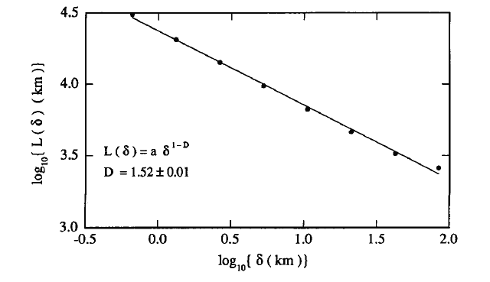
Figure 8.1 Fractional Dimension of the Coastline of Southern Norway
(Feder, Fig. 2.2, p. 8)

The coastline observation led Mandelbrot to apply the mathematical concept of a fractal set and fractional dimension in describing such objects. It was shown in Lecture 7 (Eq. (7.4)) that the length of a self-similar curve is,

(8.2)

Taking logs on both sides gives the equation of a straight line , where,. We can fix different values of the length of a measuring stick s, and measure the corresponding lengths of the coastline, . This way many data points for the pairs (, ) are obtained. They plot as a straight line with slope m, as shown in Fig. 8.1. Using the slope, m = -0.52 for the coast of Norway gives . It can be interpreted as a fractional dimension, or a box-counting dimension, of the coastline of Norway, as explained below. Well-known geometrical objects, such as the circumference of a circle, area of a square or a circle, have an integer dimension. By contrast, the coastline of Norway is neither one nor two-dimensional. Rather it has a fractional dimension, . Mandelbrot coined the term Fractal to denote geometrical objects with a fractional dimension.

8.2 Box-Counting Dimension
The concept of dimension for simple curves is rather well known, but let us review it. Consider a smooth curve, for example, a circle. In order to measure the circumference of this curve, take a ruler of side length and count the number of arcs of the ruler that cover it. We also know that the size of the ruler cannot be too large, otherwise it would introduce errors in our measurement. On the other hand if we take many rulers of successively smaller sizes, then we expect the length measurements to be close to each other, say . Mathematically it can be expressed as,

(8.3)

Taking logs of both sides, dividing by , and taking the limit as ,

(8.4)

This result gives the dimension of the curve in terms of its length measurement as 1, which is well known to all of us. For small , we can also write (8.4) as

, (8.5)

What about the area of the circumference of a circle? We can consider small squares of area and compute the area of the circumference in a similar manner as above. This gives,

, (8.6)

as expected. By contrast, if we consider the area enclosed by the circle, it can be obtained as,

(8.7)

This equation gives the dimension of the area as 2. It can be written as,

(8.8)

However, the length of the set enclosed by a circle is,

(8.9)

This is reasonable, because the length of an object in two dimensions should be infinite.

Definition
The box counting dimension of a set F in the d-dimensional Euclidean space is defined as,
(8.10)
or,
(8.11)

Here denotes the number of closed balls of radius that cover F, or the number of cubes of side that cover F.
There are other notions of dimension, e.g., entropy dimension, Hausdorff dimension, but we will not venture out into this advance mathematical territory in this course. The interested reader may refer to Feder (1988), which contains a large number of physical examples, and some of them are from hydrology. There are numerous examples of geometrical objects in a plane that have an infinite length and zero area, i.e., they are neither one- nor two-dimensional. These objects have a fractional dimension, 1< <2, which can be computed from Eq. (8.10). This concept holds in general in a d-dimensional Euclidean space. A common property of fractal curves is geometric self-similarity that was introduced in Lecture 7. Repeating an operation over an over again on smaller scales culminates in a self-similar structure. The repetitive operation can be algebraic, geometric, symbolic, dynamic or statistical. We illustrated in Lecture 7 that self-similarity is produces the functional equation, , whose solution is a power law. Two well-known mathematical examples are given below that show how self-similar objects are constructed by repeating a geometrical operation over an over again to smaller scales.

8.3 Two Examples of Box-Counting Dimension of Fractal Objects
Consider a line of unit length, called an initiator. Divide this into three equal parts, remove the middle third, and erect an equilateral triangle over it, called a generator. The length of the new line is 4/3 the length of the initiator. This number comes from multiplying the number of segments with length of each piece . Repeating once more the operation of erecting equilateral triangles over the middle third of the straight line segments now gives pieces, and each is of length . After n steps one obtains by induction that pieces, each of length . Notice that the length of the curve becomes infinite as the number of steps, n, goes to infinity. At each stage of construction, the curve that is obtained is called a prefractal. Construction of prefractals holds the clue to computing the fractal dimension. For our example, the box dimension from Eq. (8.10) is,

(8.12)

This curve, named after the Swedish mathematician Helge von Koch, is known as the Koch Curve.
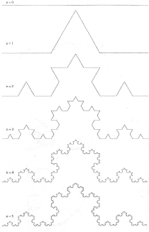
Figure 8.2 A Koch Curve (Feder, Fig. 2.8, 1988)

The second well-known example is that of the Cantor set that is named after a German mathematician George Cantor. Consider a line of unit length. Divide this into three equal parts, and remove the middle third open interval. Take the remaining two pieces, each of length 1/3, and remove the middle third again. It is clear that at the n^{th} stage of construction one has pieces removed, and each is of length,. As , the limiting set of points that are not removed is called the Cantor set. It has non-intuitive properties. For example, the total length of the segments removed is,

(8.13)

The Cantor set contains as many points as contained in the unit interval that we began with. (called the "cardinality" of the Cantor set). How is this possible? To understand this technical idea, background in modern mathematical analysis is required. So, we will skip the proof in this course. The fractal dimension of the Cantor set is given by,

(8.14)

Numerous other examples are given in your reference books, which I urge you to read.

8.4 Cloud and rainy area-perimeter relationship as a fractal
For smooth objects, for example a circle of radius r, the perimeter is. Hence its area as a function of the perimeter is,

Taking logs on both sides gives an equation of a straight line with slope 2,

,

Now suppose that P is a fractal curve, and write it as ( Eq. (8.2)), where is the box counting dimension. Therefore,

Taking logs on both sides,

(8.15)

Plotting area versus perimeter on a log-log plot and measuring the slope, , gives the dimension of the perimeter,

(8.16)

For circles, , and =1 as it should be. However, for clouds and rainy areas one uses boxes of different sizes, and then applies the box counting method to find the areas (=) and perimeters (). A log-log plot of area versus perimeter in Fig. 8.3 shows that , so the perimeters of clouds and rainy areas are fractals with a dimension . Refer to Schroeder (1991, Figure 16, p.231) for more details of this example.
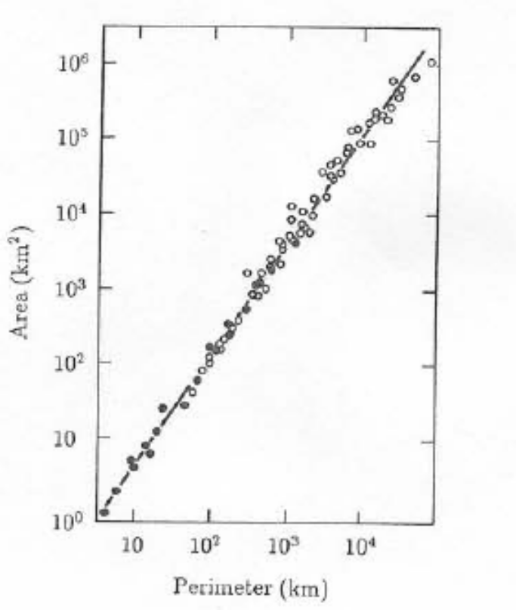
Figure 8.3 Cloud Perimeter-Area relationship (Schroeder, 1991)
REFERENCES

Feder, J. Fractals. Plenum, 1988.

Mandelbrot, B.B. The Fractal Geometry of Nature. Freeman, 1983.

Rodriguez-Iturbe I, Rinaldo A. Fractal river basins. Cambridge,1997.

Schroeder, M., Fractals, Chaos, Power Laws. Freeman, 1992.

Turcotte D., Fractals and Chaos in Geology and Geophysics. 2nd ed., Cambridge, 1997.

